**CS4471**

**Lab Assignment 1  
LAN Wiring and Physical Topology**

**Group Number: 18**

**Group Members:**

SmitKumar Patel CIN: 306587208

Riddhiben Patel CIN: 306612701

Alejandra Monteon CIN: 302203894

**Question 1**

**a. (10 pts) Using the ETC245 network diagram as reference, connect your lab computer to a Cisco Ethernet switch with an Ethernet cable. On the Cisco switch, which port number did you use? What pin numbers (not port numbers) on the RJ45 jack are used for transmitting and receiving data?**

**Answer:**

On the Cisco switch the port that was used was: The Console Port

On the RJ45 jack pin numbers used for receiving data: Pins 1-2

On the RJ45 jack pin numbers used for transmitting data: Pins 3-6

**b. (10 pts) What is the difference between a straight-through Ethernet cable, a crossover  
Ethernet cable, a rolled (rollover) cable, and a serial cable? Under what circumstances would  
you use each of the aforementioned type of cable?**

**Answer:**

A Straight-through cable is mainly used between a computer and modem, as well as a switch or router. This cable has the pin assignments on each end of the cable and is used to connect computers, printers and other network client devices to the router, switch or hub. Example, Host to switch or hub, and Router to Switch or Hub. Pin 1 connector A goes to Pin 1 connector B.

A crossover cable is used for either connection between two computers or connection between two similar networks. In more detail, a crossover cable can connect: switch to switch, hub to hub, host to host, a router directly to a host and a router to a router. In a crossover cable example, Pin 1 on connector A goes to Pin 3 on connector B.

The Rolled cables have opposite pin assignments on each end of the cable. Rollover cables are often called Yost cables, and are most commonly used to connect to a device’s console port to make programming changes to that device. Unlike the crossover and straight-through cables, the rollover cables are not intended to carry data, instead they are used to create an interface with the device. Serial cables are used for data communication between the device. In a rollover cable, Pin 1 connector A will go to Pin 8 connector B.

Serial cables transfer data between devices that use bit-by-bit or port communication techniques.

**Question 2. Use the World-Wide-Web to locate 2 Ethernet hubs and 2 Ethernet switches manufactured by different manufacturers.**

**a. (10 pts) List manufacturers’ name, URL of website, and model numbers of the hubs and Switches.**

**Answer:**

|  |  |  |
| --- | --- | --- |
| ***Ethernet Hubs*** | | |
| **Manufacturer** | **URL of Website** | **Model No.** |
| Linksys | <https://www.linksys.com/us/support-product?pid=01t80000003K7dLAAS> | EFAH08W Version 3 |
| IOGEAR | <https://www.iogear.com/product/GUH285W6/> | GUWIP204 |

|  |  |  |
| --- | --- | --- |
| ***Ethernet Switches*** | | |
| **Manufacturer** | **URL of Website** | **Model No.** |
| TP LINK | <http://www.tp-link.com/no/products/details/cat-42_TL-SF1005D.html> | TL-SF1005D |
| Cisco | <https://www.cisco.com/c/en/us/products/collateral/switches/catalyst-4900-series-switches/product_data_sheet0900aecd8017a72e.html> | WS-C4948-S |
| TP LINK | <http://www.tp-link.com/us/products/details/cat-42_TL-SG108.html> | TL-SG108 |

**b. (10 pts) What media types and what network speeds do these hubs and switches support?**

|  |  |  |  |
| --- | --- | --- | --- |
| ***Ethernet Hubs*** | | | |
| **Manufacturer** | **Model No.** | **Media Type** | **Network Speed** |
| Linksys | EFAH08W | Network | 10Mbps / 100Mbps (Auto) |
| IOGEAR | GUWIP204 | Network | 480 Mbps |

|  |  |  |  |
| --- | --- | --- | --- |
| ***Ethernet Switches*** | | | |
| **Manufacture** | **Model No.** | **Media Type** | **Network Speed** |
| TP LINK | TL-SF1005D | Network | 10/100MBPS |
| Cisco | WS-C4948-S | Network - Twisted Pairs | 1000MBPS / 1GBPS(Auto) |
| TP LINK | WS-C4948-S | Network - Twisted Pairs | 1000MBPS |

**c. (10 pts) What is the difference between an Ethernet switch and a shared Ethernet hub?**

**Answer:**

A Ethernet hub is designed to connect computers to each other with no real understanding of what is transferring. Typically, it is used as private network whereas a Switch also connects the computers to each other like hub but it is differs from hub is in the way it handles the packet of data.

When a hub is receiving the data from a connected device, it broadcast that data packets to all other connected devices regardless the consideration of final destination in contrast switch is broadcast the packet of data to that, which device is intended for, and sends only that one.

In hub bandwidth of network is shared to the all computer so it splits all over the connected network so less bandwidth leads to a slower connection speeds but in hub is not shared so it makes the network more efficient. For this reason, switch is more preferred over the hub.

Hub is passive device we can use without software, switch is passive device software is must be needed with networking devices.

Collision occur in set up using hub but in switch no collision occurs in switch full duplex switch.

**Question 3. (50 pts) Suppose you had to design a wired Ethernet network for a 4-story office building containing 20 users per floor. Each floor is 90 meters in length and 5 meters in height. Draw a network topology of your proposed design using Cisco equipment. The access-layer switches must support 1Gbps to each user’s desktop computer and have 10Gbps uplink capability. Specify in the drawing.**

**(i) the model number of each Cisco equipment used:**

**Answer:**

**Equipment used for Router**:

* Cisco 4-Port High-Density Gigabit or 1-Port 10 Gigabit Ethernet WAN Service Module (SM-X-4X1G-1X10G), more information about this router can be found here: [Cisco Website](https://www.cisco.com/c/en/us/products/collateral/routers/4000-series-integrated-services-routers-isr/datasheet-c78-730527.html): <https://www.cisco.com/c/en/us/products/collateral/routers/4000-series-integrated-services-routers-isr/datasheet-c78-730527.html>

**Equipment used for Switches:**

* Cisco Catalyst 3850 Series (3850-24XU) will be used to connect the LAN machines on each of the four floors.
  + Listed on the cisco website, the Switch has the following features:
    - 24 multi gigabit ports
    - 24 UPOE ports
    - Supports Cisco StackPower
    - Supports 8x10G and 2x40G uplinks
    - Enhanced Limited Lifetime Warranty (E-LLW)

**(ii) the part number of 10 Gbps transceivers used:**

**Answer**

**Equipment used:**

* Cisco SFP-10G-LR-S Module 10GBase, listed on the cisco site, the SFP-10G-LR-S Module has the following features/benefits:
  + Main features of Cisco 10GBASE SFP+ modules include:
  + Smallest 10G form factor
  + Commercial temperature (0 to 70°C) only
  + Supports 10GBASE Ethernet only
  + Hot-swappable input/output device that plugs in to an Ethernet SFP+ port of Cisco platforms
  + Provides flexibility of interface choice
  + Supports digital optical monitoring capability
  + Cisco quality identification (ID) feature that enables a Cisco platform to identify - optics supported by Cisco technology
  + Optical interoperability with 10GBASE XENPAK, 10GBASE X2, and 10GBASE XFP interfaces on the same link
  + Cisco SFP-10G-SR-S
* Therefore, we will be using Cisco SFP-10G-LR-S Module 10GBase as the transceiver.

**(iii) the type of cabling used for connecting the users’ computers:**

**Answer:**

**Equipment used:**

* We will be using the following cables for connecting the user’s computer:
  + Cat 6A Ethernet Cable - Supports 10 gigabit per second network for full distance of ethernet (328 ft)
  + Cat 7 Ethernet Cable
* These cables can be used to support gigabit speed and long full distances, since each floor is 90 meters in length and 5 meters in height, the two cables above provide the best service.

**(iv) the type of cabling for interconnecting the network equipment:**

**Answer:**

**Equipment used:**

* The type of cabling that will be used for interconnecting the network equipment will be through bus topology. The 20 computers placed on each floor will be connected through Bus to the switch placed on that floor. Each switch placed on each floor will be connected to the Cisco router. And lastly, the router will be connected to the Internet (WAN network). Example: On the first floor, 20 computers will be connected to Switch 1, each of the four Switches will be connected to the Router and the Router will be connected to WAN network.

(**v) the location where each network equipment will be placed:**

**Answer:**

**Locations:**

* **For Router:** The router can be located anywhere in the building, as long as it can connect to the Internet service provider.
* **For Switches:** One switch will be placed on each floor.

**NETWORK TOPOLOGY:**

**CISCO ROUTER**

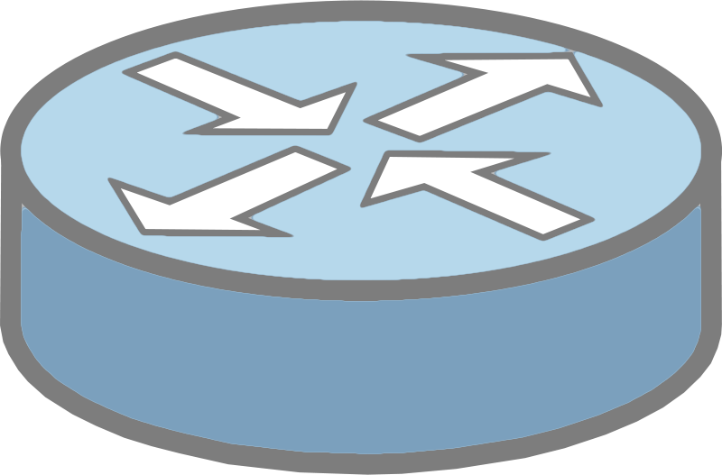



**20 USERS**

**SWITCH 4**

**20 USERS**

**FLOOR 3**

**FLOOR 4**

**SWITCH 1**

**SWITCH 2**

**FLOOR 2**

**20 USERS**

**FLOOR 1**

**SWITCH 3**

**20 USERS**